VOLUNTEER APPLICATION

FOR OFFICE USE ONLY
Background Check Date:___/ ___ / ___
References Checked By: ___________
KidTrax Club ID #: ______

BASIC INFORMATION

First Name:
Last Name:
Suffix:
Date: / /

Address:
City:
State:
Zip:

Mobile Ph: ______ - ______ - ___________
Work Ph: ______ - _______ - ________

Email:

Emergency Contact Name: ____________________ Emergency Contact Phone: _____ - _____ - ____________

Are you seeking to volunteer in order to satisfy a court-ordered community service? YES NO

If yes, please explain: _______________________________________________________________________________________________________________

SKILLS AND EXPERIENCE
What is your educational background?

What hobbies, interests and activities do you enjoy?

What is your occupation?

Do you have past volunteer experience?

To help us determine which volunteer activities you might like to participate in, please check all areas that interest you:

Homework Help | Music/Songwriting | Nutrition Program | Assisting with Events/Fundraising
Athletics Leagues | Arts & Crafts | Chaperoning Field Trips | Mentorship
Daily Gym Activities | Reading | STEM/Computer Science | Teen Programs

Please list any other strengths or passions you have that you might like to share with Club members:

AVAILABILITY
Please provide the days/times you wish to volunteer:

MONDAY:
TUESDAY:
WEDNESDAY:
THURSDAY:
FRIDAY: __________

Please check which closest represents the frequency you wish to volunteer:

1-2 times/week 3-4 times/week 1-2 times/month Specific program/event only

EMPLOYMENT

Current Employer:
Supervisor Name:
Phone ______ - _______ - __________

Address:
City:
State:
Zip:

Would you like us to notify your employer of your volunteer service (circle one)? YES NO

Does your employer participate in a “matching grant” program for hours served at non-profit organizations (circle one)? YES NO DO NOT KNOW

Please list two references who know you well and can attest to your character, skill, and dependability:

Name:
Phone: ______ - _______ - __________
Years Known:

Name:
Phone: ______ - _______ - __________

Years Known:

ADDITIONAL INFORMATION

Do you currently use illegal drugs? YES NO

Have you ever been convicted of an illegal offense? YES NO

Have you ever been convicted of child abuse or neglect or is there a pending criminal charge against you for child abuse or neglect? YES NO Has your driver’s license ever been suspended or revoked? YES NO
Are there any other facts of circumstance, involving you or your background, which would call into question you being entrusted with supervision and care of young people? YES NO

If you answered “YES” to any of these questions, please explain in further detail:

PLEASE FILL OUT THE ATTACHED BACKGROUND CHECK CONSENT FORM

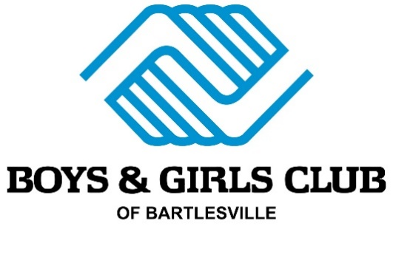
FOR OFFICE USE ONLY
This background check is for a (circle one): Employee Volunteer Other
If Other, please explain: ______________________________
Screened by: ______
Entered into KidtRax by: ______
Club ID #: ______

BACKGROUND INVESTIGATION CONSENT

I, (print full name) _____________________________________________, hereby authorize Boys & Girls Club of Bartlesville and/or its agents to make an independent investigation of my background, references, character, past employment, education, credit history, criminal or police records, including those maintained by both public and private organizations and all public records for the purpose of confirming the information contained on my Application and /or obtaining other information which may be material to my qualifications for employment now and, if applicable, during the tenure of my employment or volunteer duty with the Boys & Girls Club.

I release Boys & Girls Club of Bartlesville and/or its agents and any person or entity, which provides information pursuant to this authorization, from any and all liabilities, claims or law suits in regards to the information obtained from any and all of the above referenced sources used.

The following is my true and complete legal name and all information is true and correct to the best of my knowledge.

First Name: _________________________________ Middle Initial: ______ Last Name: _______________________________
Maiden Name or Other Names Used: ____________________________________
Mobile/Home Phone: ______ - ______ - __________ Work Phone: _______ - ______ - __________
Email: _________________________________________________________________________________
Current Address: __________________________________ City: ________________________ State: ______ Zip: _________
How long have you been at this address? _____ Years _____ Months (If less than 2 years, please fill out Former Address below)
Former Address: ___________________________________ City: ________________________ State: ______ Zip: _________

Social Security Number: ________ - ________ - ________________ Date of Birth: ______ / ______ / _________
Driver’s License Number: __________________________________ State of Issue: _________

Signature: ______________________________________________ Date: ______ / ______ / _________
IF UNDER 18 – PARENT SIGNATURE REQUIRED

Parent Name: __________________________________________ Parent Signature: ___________________________________

NOTE: The above information is required for identification purposes only, and is In no manner used as a qualification for employment or volunteering. Boys & Girls Club of Bartlesville is an Equal Opportunity Employer, and does not discriminate on the basis of Sex, Race, Religion, Age (40 and over), Handicap or National Origin

